Scremerston First School Weekly Newsletter
15th March 2024

This week’s question of the week for discussion at home…Should mobile phones be banned in all classrooms?

This week in photos…
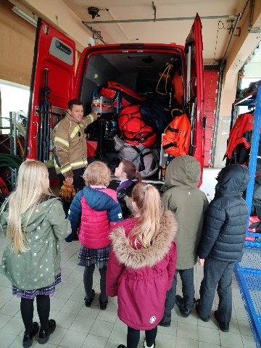
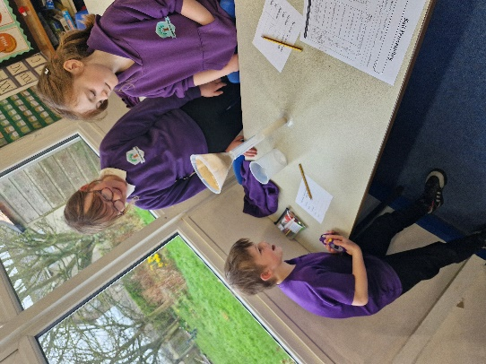
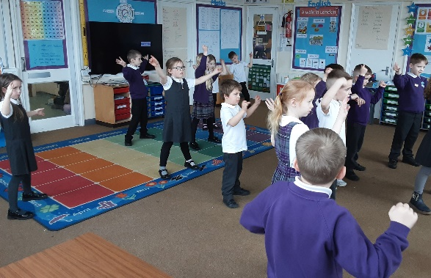

Thank you to everyone who supported our PTFA Bingo & Quiz night! It was a brilliant night all round and raised a wonderful £179.20 towards resources and trip costs!

Reminders
- Please send in Bikeability consent forms on Monday if you haven’t done so already.
- We need your help! Please send in red, orange, yellow, green, blue and purple plastics to help us decorate our Riding of the Bounds horse.
- Parents meetings have been booked in, if you don’t have an appointment or you need to change your appointment, please let us know as soon as possible.

Foodbank Donations
We would love to donate some Easter treats to the local foodbank so if anyone would like to contribute, please bring donations in to school by Tuesday 26th March!
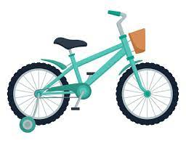
Dates for your Diary
Tue 19th March – Bikeability – Reception & Year 4
Tue 19th March – Y4 Ford Residential Parent’s Meeting 3.10pm
Wed 20th March – Class Group Photos & Leaver’s Photos
Thu 21st March – Bikeability – Year 1
Fri 22nd March – Bikeability – Year 2 & Year 3
Tue 26th March – Easter Craft Morning – parents/family welcome
Wed 27th March – Easter Church Service 9.30am – parents/family welcome
Thu 28th March – Easter themed Baby & Toddler Group 10am – 11am all welcome

Star Of The Week Awards

Rory J
For super knowledge of the life cycle of a frog!

David
For trying something new with such enthusiasm, having great fun doing it!
Trixie & Beau
For always being great helpers, but this week they have particularly gone over and above helping in class without needing to be asked!

Noah
For setting his mind to something and not giving up until he has succeeded!

Super Work Of The Week Awards

Ellie
For fantastic use of Fred Fingers when constructing sentences!

Hannah
For great knowledge and understanding of the great fire of London!

Robyn
For a detailed summary of why the Anglo Saxons invaded Britain!
Elena-Mai
For great examples of how to show not tell in your writing!

Well Done Everyone!!

