Scremerston First School Weekly Newsletter
22nd March 2024

This week’s question of the week for discussion at home…What’s the best way to handle disappointment?

This week in photos…
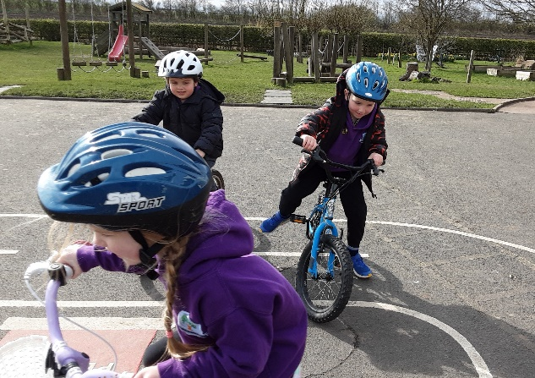
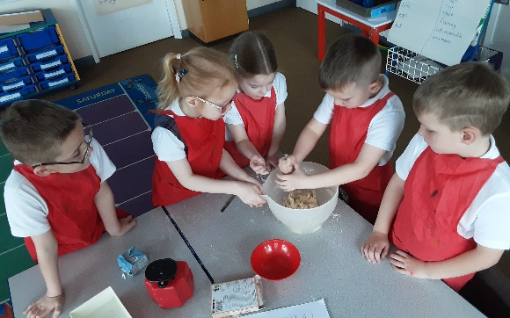
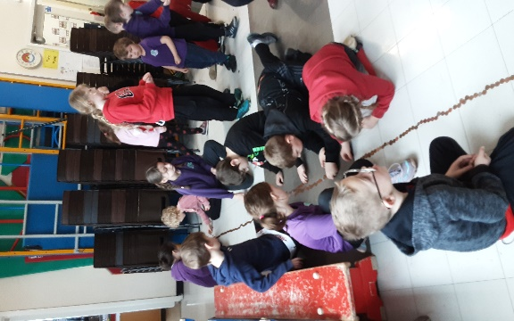

Thank you to everyone who supported Comic Relief last Friday…we raised an impressive £101.02 for the charity!! We managed to get right round our hall floor with the pennies donated and including other denominations we counted over 3500 coins!

Reminders
- Parents meetings have been booked in for next week. If you don’t have an appointment or you need to change your appointment, please let us know as soon as possible.
- Our Easter Raffle will be drawn next week…tickets are £1 per strip and there is a beautiful Easter hamper to be won! Pop in to the office for tickets.
- Foodbank Donations. We would love to donate some Easter treats to the local foodbank so if anyone would like to contribute, please bring donations in to school by Tuesday 26th March!
- Ragbag. We have a Ragbag clothing bank in the school car park. If anyone is having a Spring clear out and has any clothing items, paired shows, bags, belts etc. they want rid of, please feel free to pop it in our Ragbag bank!

Dates for your Diary
Tue 26th March – Easter Craft Morning 9am – parents/family welcome
Wed 27th March – Easter Church Service 9.30am – parents/family welcome
Thu 28th March – Easter themed Baby & Toddler Group 10am – 11am all welcome

Star Of The Week Awards

Sophie
For a positive attitude to her learning this week!

Skylah
For listening well & taking care & attention when baking!

Vince
For growing confidence in his abilities and developing a can do attitude!

Super Work Of The Week Awards

Angus
For recalling what the Hungry Caterpillar ate!

Reid
For neatly presented, detailed set of instructions for bread making!

Paige
For confidence when dividing 2 digit numbers using the part/whole method!
Lochlan
For a fantastic diagram of an Anglo Saxon village!

Well Done Everyone!!

