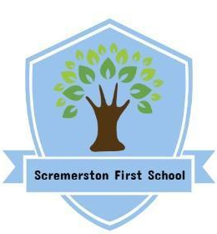
Scremerston First School Weekly Newsletter
28th March 2024

This week’s question of the week for discussion at home…What does the word ‘rich’ mean to you?

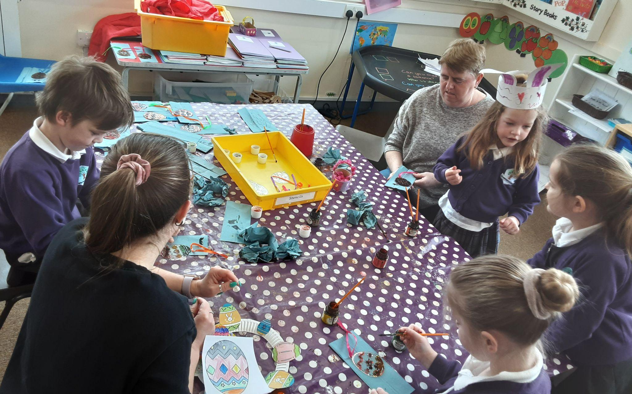
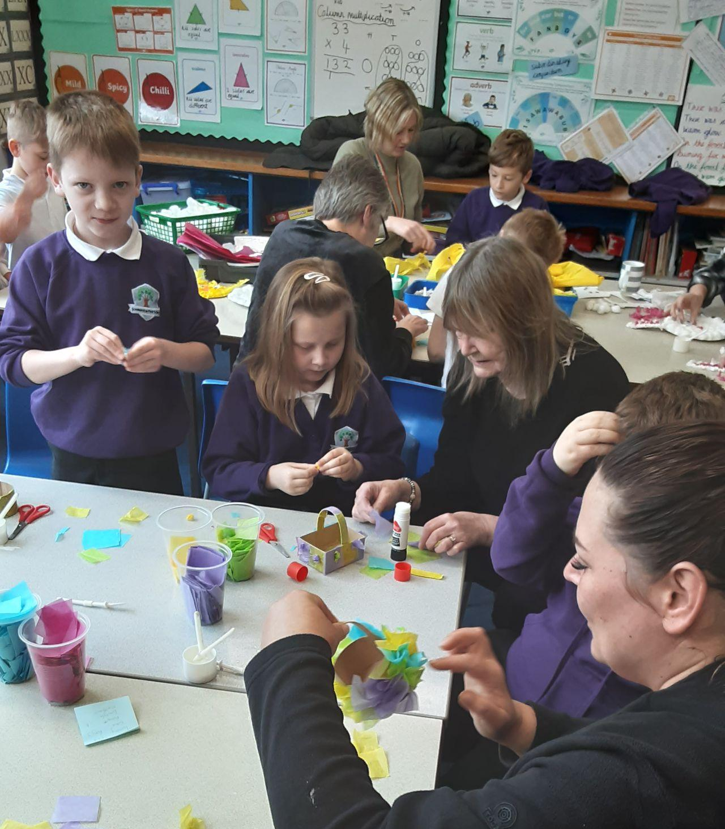
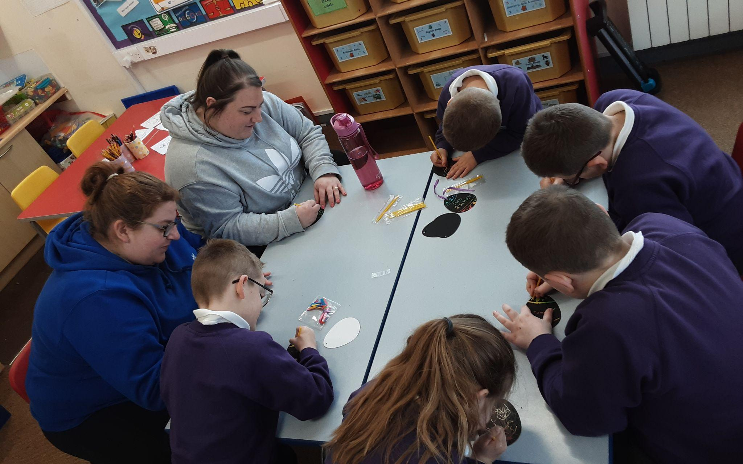
Our Easter Craft Morning was a huge success…we think everyone enjoyed the slightly muddy Easter Egg Hunt too!

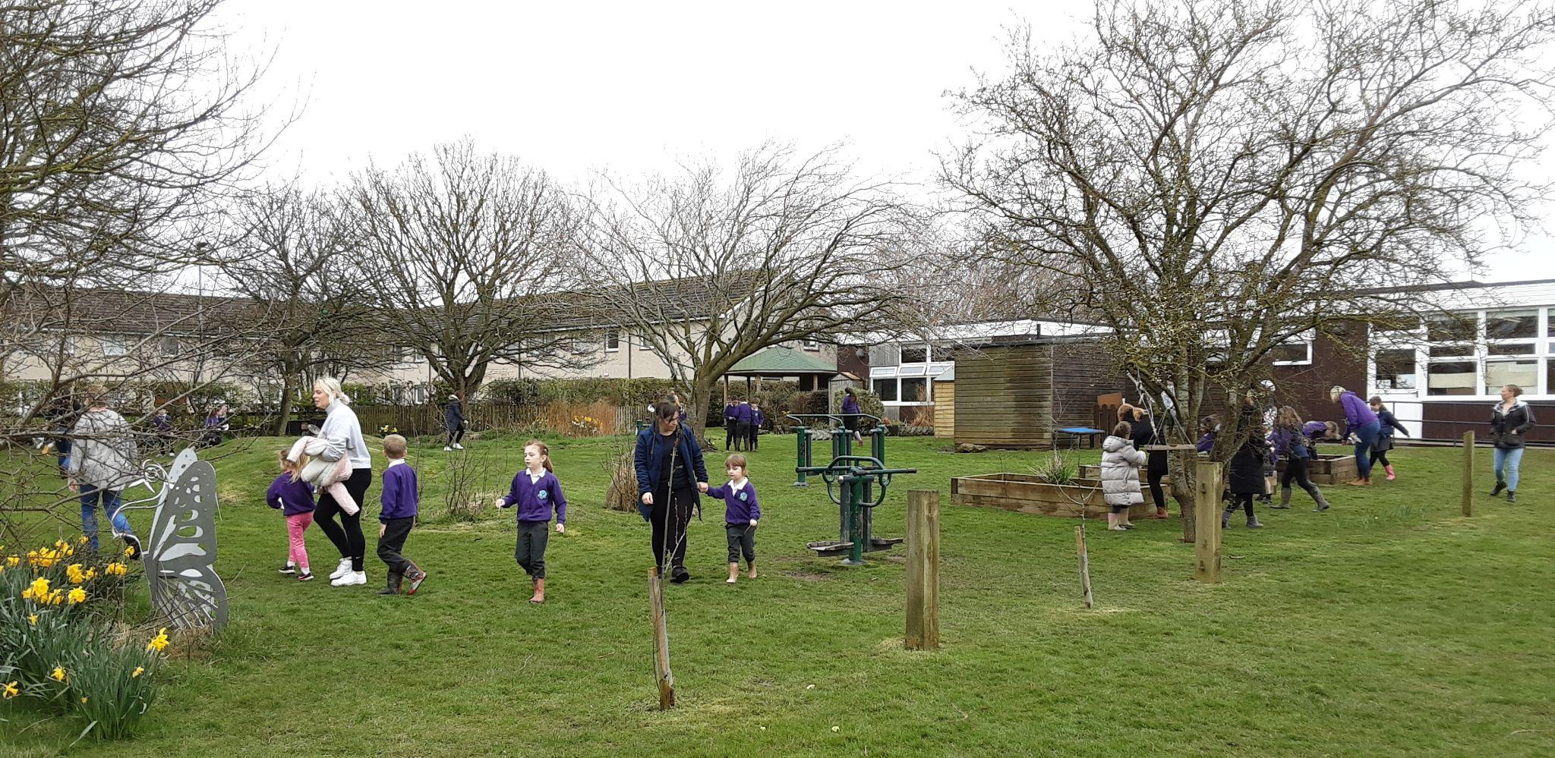
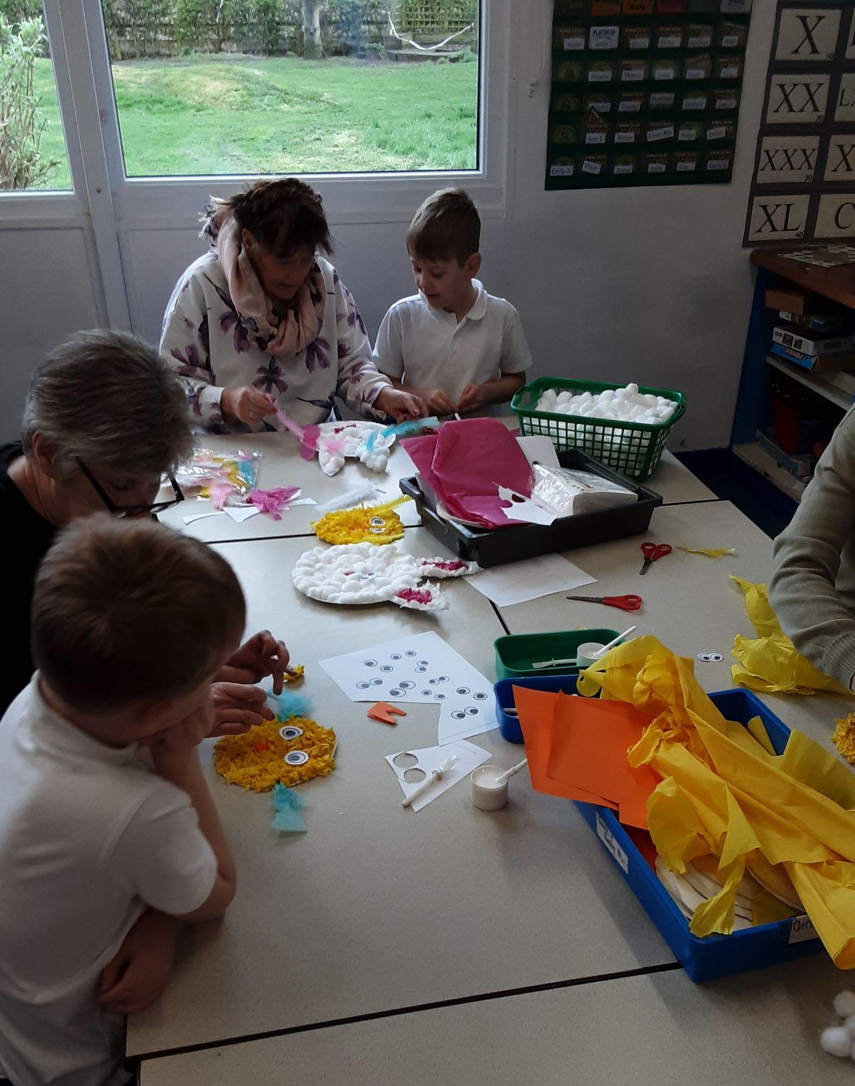

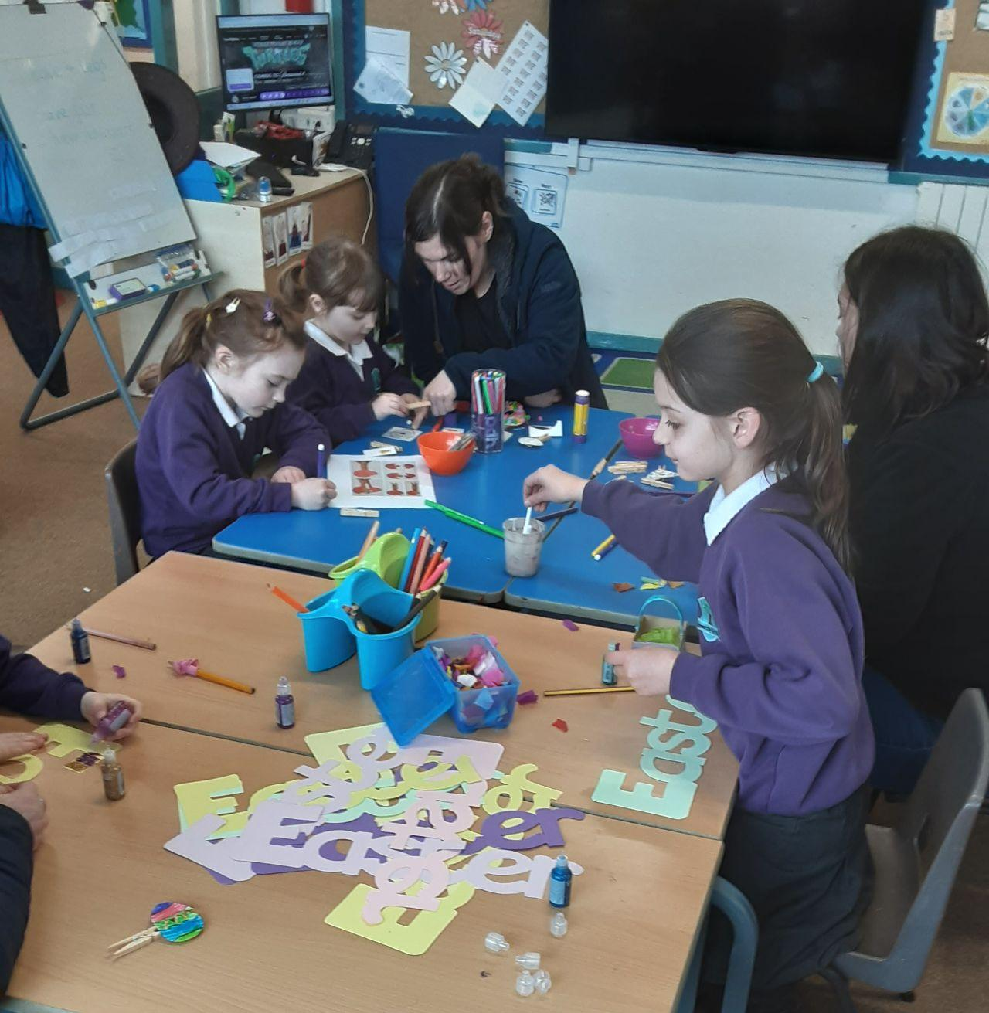

Thank you to everyone who has supported our PTFA Easter fundraising by coming to our Bingo/Quiz night and/or buying raffle tickets for our wonderful Easter Hamper! We have raised an impressive £160.40 to add to our trips fund!
Thank you to our PTFA for buying all of the children an Easter egg as part of the Easter egg hunt! We don’t think they lasted long!

P.E. Days next half term…
Tuesday - Oak & Ash Rugby
Wednesday - Year 2, 3 & 4 Swimming
Thursday - Elm & Oak Commando Joes

Happy Easter, we hope you have a chance to enjoy some time together over the next two weeks!
We re-open on Monday 15th April.

Star Of The Week Awards

Sierra
For being a good friend and including all children in her game!

Rory I
For his effort in phonics!
Iva
For always having a positive attitude to learning, particularly in maths!

Grace
For improved resilience and happy to give everything a go with a smile!

Super Work Of The Week Awards

Rory F
For a lovely Easter acrostic poem!

Quinn
For detailed explanations of the cause, events and reasons for the spread of the Great Fire of London!
Jamison
For great improvement in artwork, taking care, time and attention!

Kobe
For working hard to improve his handwriting and presentation!
Jessica
For careful and effective colour blending in her dragon’s eye!

Well Done Everyone!!

