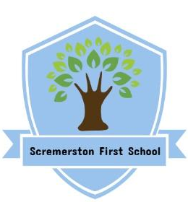
Scremerston First School Weekly Newsletter
26th April 24

This week’s question of the week for discussion at home…Can you learn to persevere?

This week in photos…
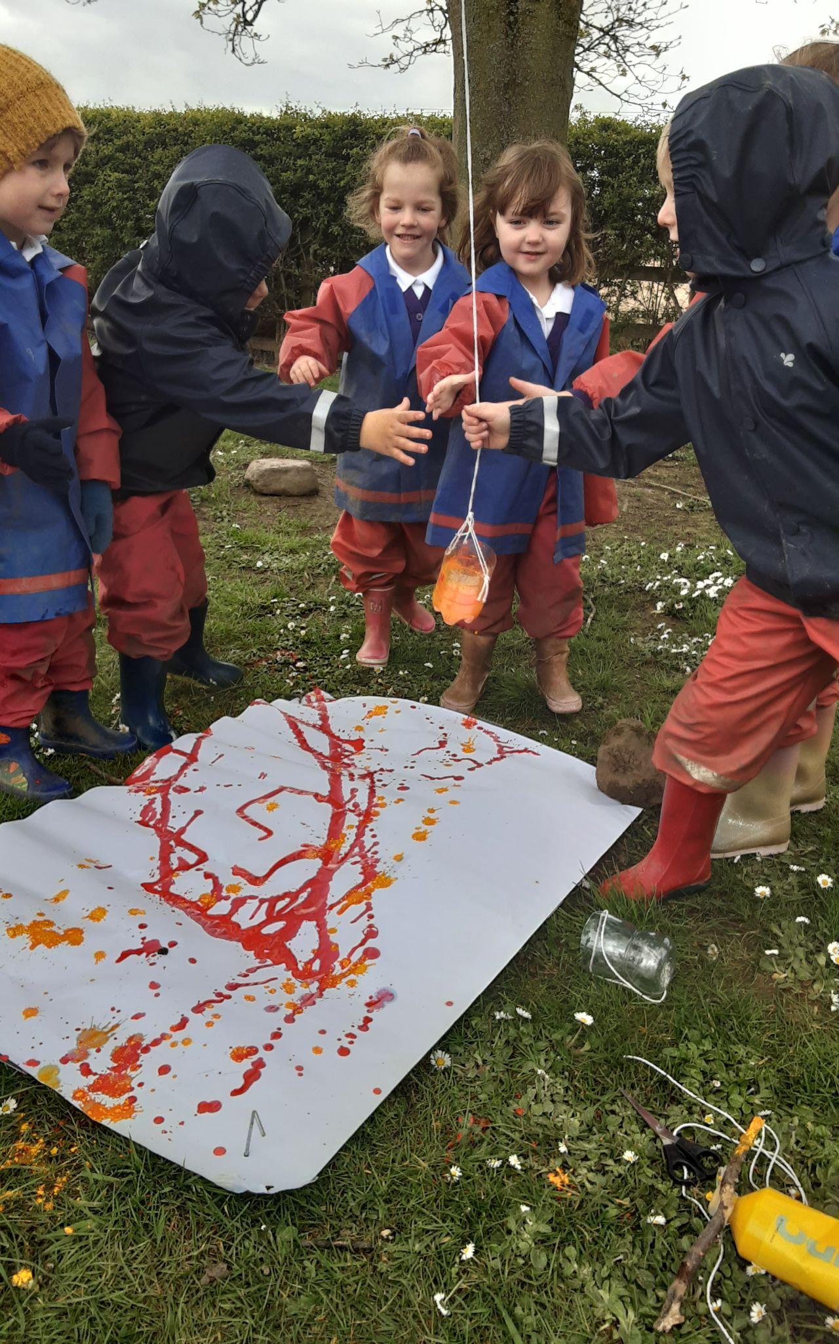
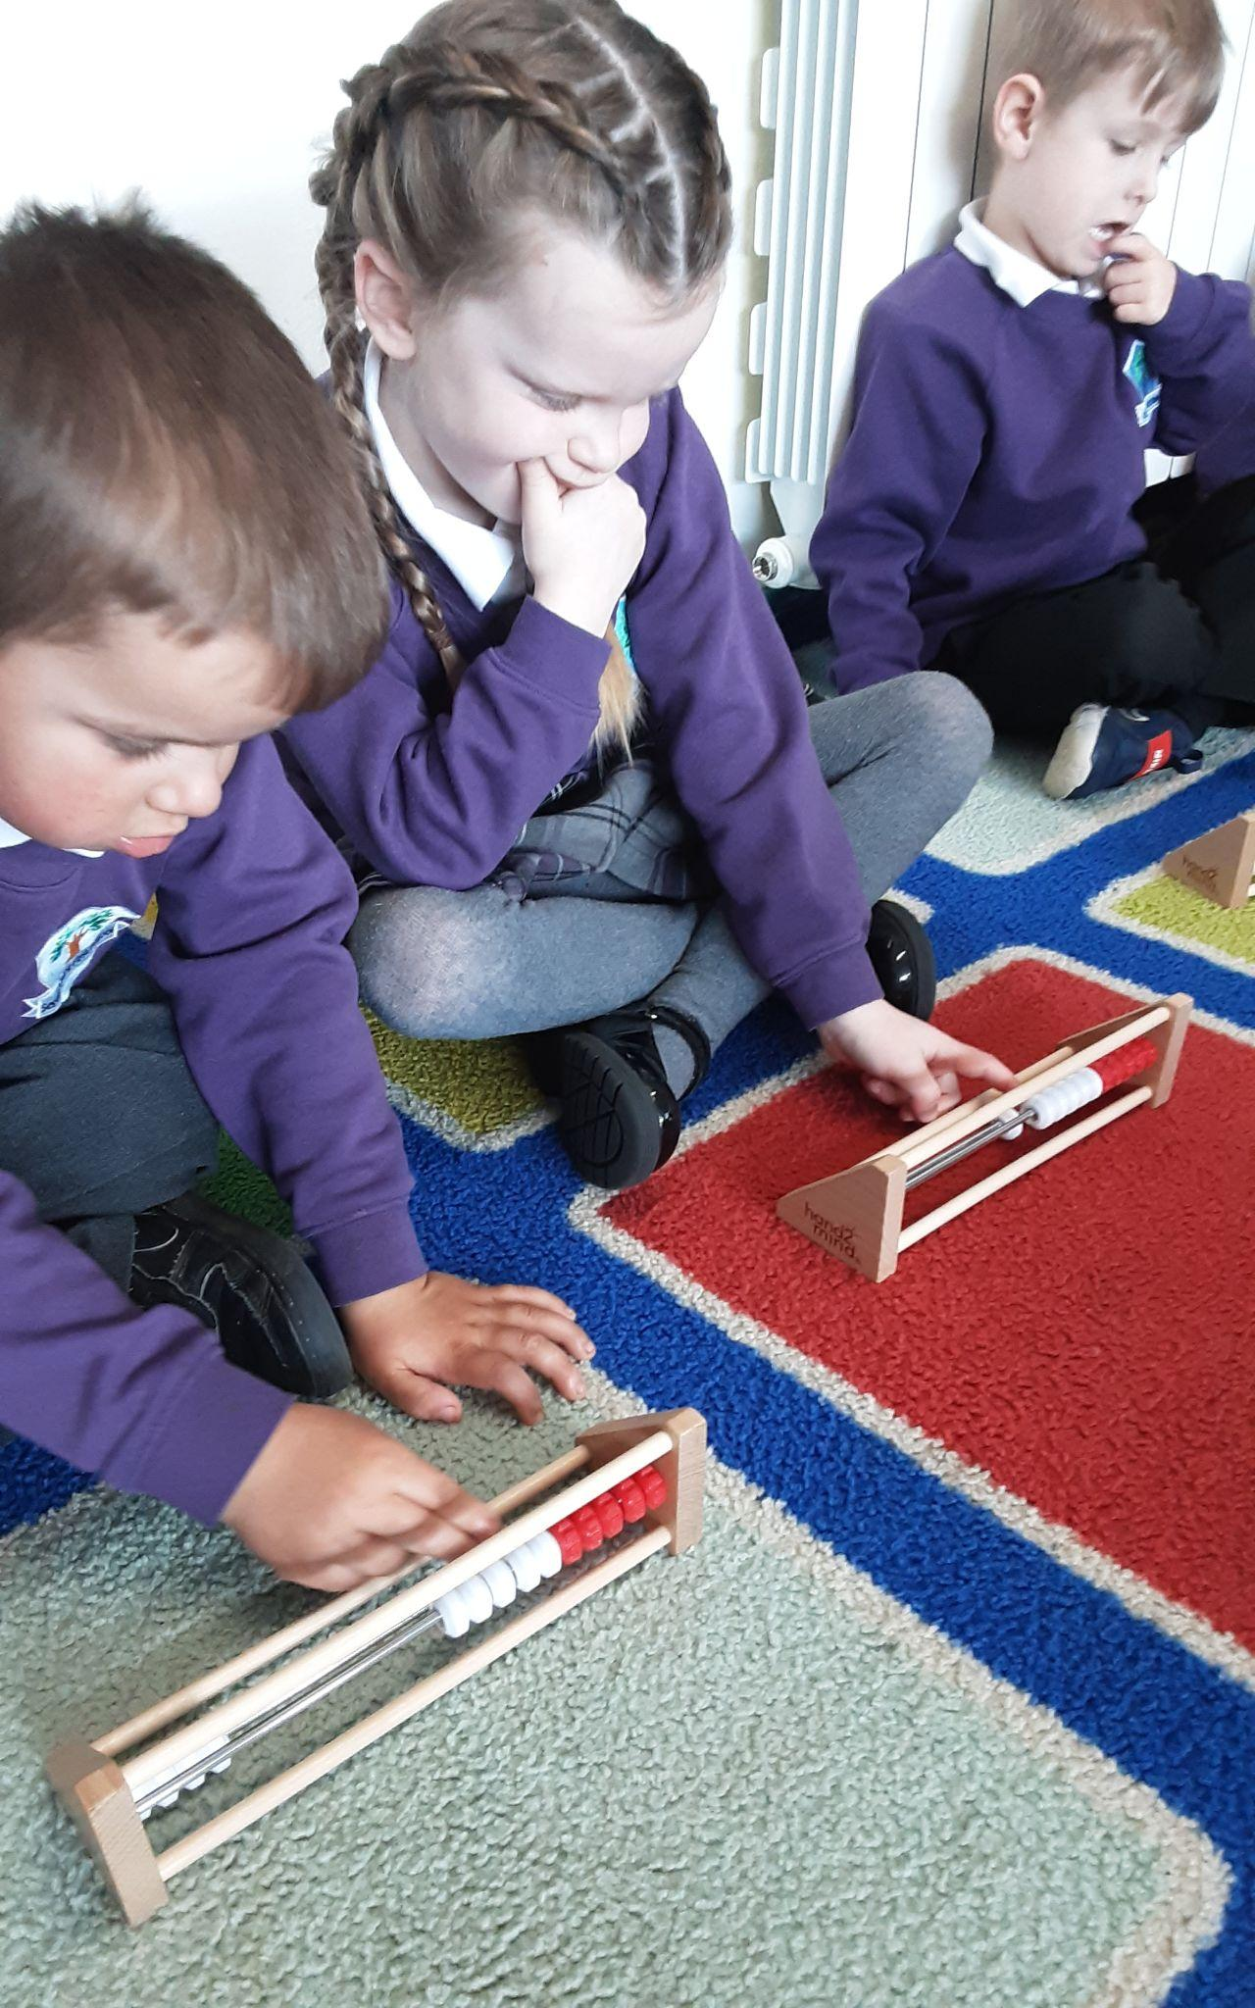
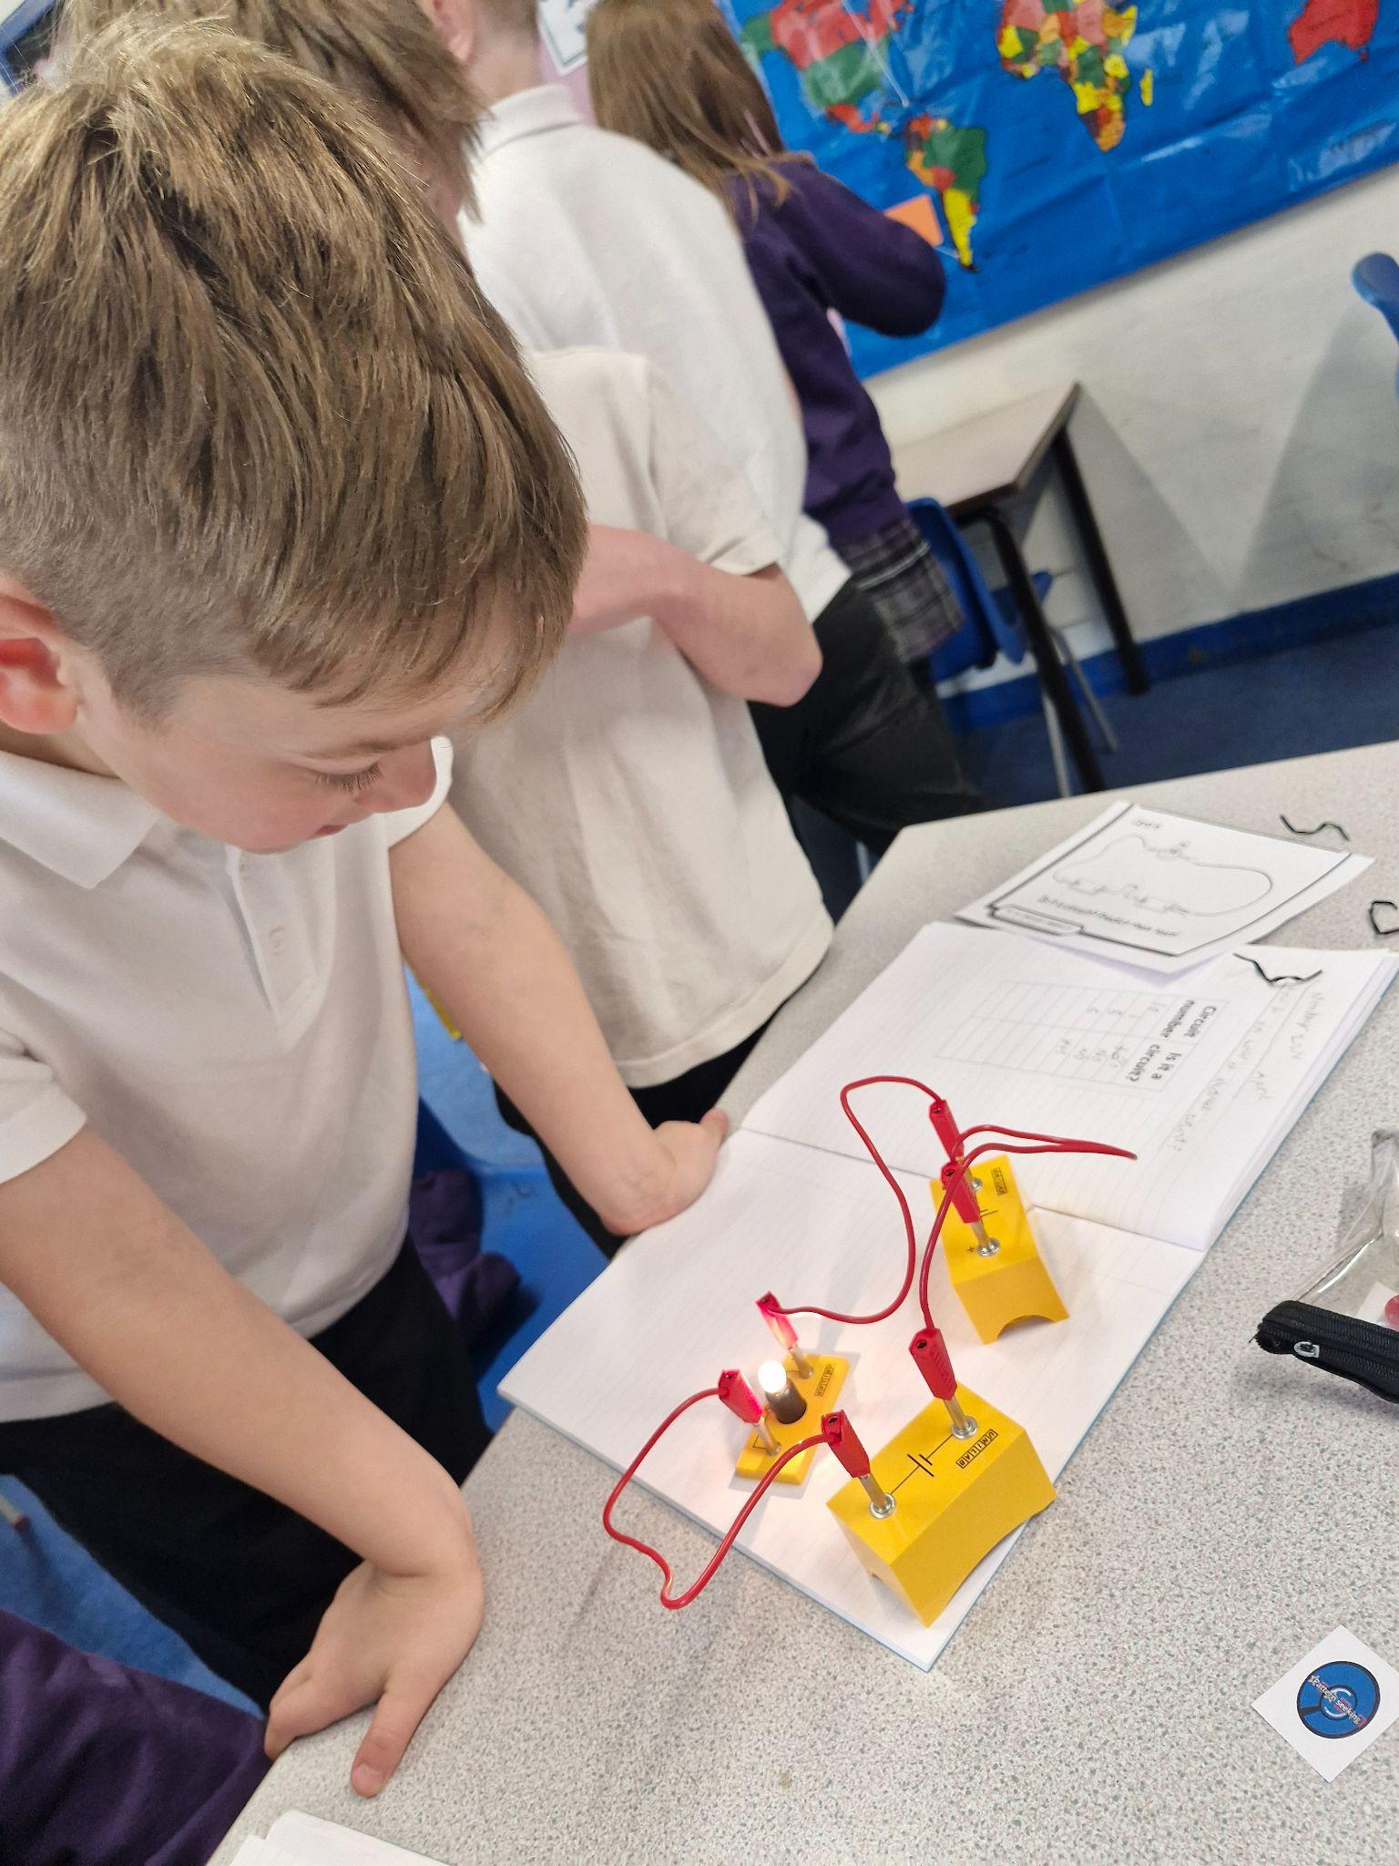

Dates for your Diary
Mon 29th April - Rugby Festival for Ash class & other schools (Ash class to wear PE Kit)
Tue 30th April - Ash class visit to Torness (Full school uniform to be worn)
Wed 1st May - Elm class trip to The Hirsel (Full school uniform to be worn)
Fri 3rd May - Crazy Hair Day! Suggested donation £1
Mon 6th May - BANK HOLIDAY - School Closed
Wed 8th May - Y4 Residential trip to Ford Castle Wed - Fri
Mon 13th May - Oak class trip to The Hirsel - letters to follow
Tue 14th May - Mr Skippy - Ash class
Fri 24th May - Dress down day - tombola donations welcome
* Please make sure your child is in appropriate school clothing & footwear for trips and they have a coat with them.

Star Of The Week Awards

Jessica
For having a positive attitude and having a smile all week!

David
For great listening and effort in all areas this week!

Ella
For a maturing attitude towards her learning by tackling challenges head on!

Super Work Of The Week Awards

Ellie
For a great independent drawing & description of Mummy Owl from ‘Owl Babies’!

Violet
For a detailed description and great explanation of why bees are important!

Grace & Sam F
For carefully labelled and beautifully presented circuit diagrams!

Well Done Everyone!!

